# Wine Seller Collection

## Design and Specification

### Description

It is a simple application that can store the wine collection. We have seen many wine enthusiastic person interested on collecting the wine. There is also constant struggle between wine proper inventory management of wine collection.

This application can store wine based on its sweetness, alcohol , acidity , body and its availability for drinking.

Features

* Real time wine inventory update using cloud database.
* Simple to use
* Supports on any platform and device
* Targeted for the smart devices.
* Faster query and simple search interface.

The system used for development of the app is as follows :

* Development Software Used : Visual code , Node package manager (NPM ) , Chrome Web tools,
* Testing Software Used: postman , chrome , safari , ios
* Programming Language: HTML , CSS , JQuery mobile , sweet alert , Node
* Database : Mongo DB ATLAS ( Cloud database

### Motivation

There were times when wine bottles had to be logged by hand in paperbound tomes or tracked using little piece of paper tagged to wine bottle. Due to active development of technology it is possible to create digital version of tracker or cellar book.

There are lot of wine cellar management apps but they are a lot complex and not easily implemented. But the rating of those app is also not so good. The most rated app among it is cellar tracker.

With the mind of issue of these app on mine we are developing the app that can address this issues and meet user requirement so our app will have popularity on the market.

I myself as wine enthusiastic, I wanted to make a pocket app that I can use to manage my wine collection as well.

### Summary of task

This is simple prototype app that can add new wine along with its property , update and perform other CRUD operation.

A user inserts the item on form provided, then the task is inserted into database which is hosted on the cloud i.e. Mongo DB atlas. Based on the

### User case Diagrams

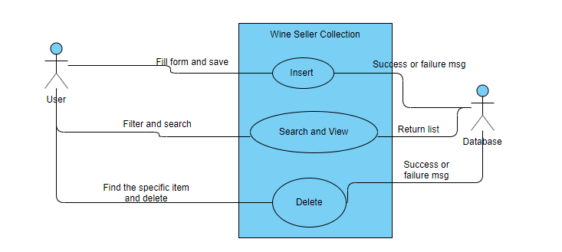

### User Interface Prototypes

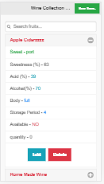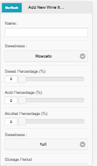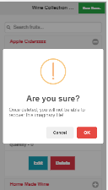

## Business Case and Marketing

### App Testing

* Unit Testing

Front end and backend was separately tested. For frontend the web browser and dev tools were used for test.

For testing backend and API of node the software called POSTMAN was used.

* Integration Testing

Using Frontend js - Jquery mobile , we update frontend dynamic and integrated frontend with backend. The module and function of our written JS was tested individually.

* Interaction Testing

For initial testing, the following browser were considered

* Safari
* Chrome
* IOS
* Android
* IE (Above 11)

We are planning to upgrade the testing using the beta version of web app provided to friends and family as well.

### Research (Literature Review)

Research was conducted on many web apps as well as mobile apps that had similar feature like our app.

There are lot of feature available on those management systems but none of categorize search based on sweetness, acidity. All wine cellar focus on alcohol and wine manufacture date and its age.

Some of the apps with a lot of reviews and comments are :

### CellarTracker

This is basically free app but voluntary donation of $40 to $160 per year is asked based on you size of collection. This is just basically to support development of the app as the wine collection keeps on growing.

On the current market the app is a winner , has phenomenal search system that filter almost all features of the wine. The real ice breaking feature is that it provides UPC scanning system.

### Cellar

This is basically simple app but it only gives 60 day trail after that you have to pay $10 per every month if you take monthly package and they offer $100 year package per year as well. This is the simplest to use app with basic inventory information available.   
But its knowledge base is shallow and database is stored locally on device. It gives the functionality to export the data but its not real time.

### Business Plan

**Cost Estimation**

* **Development Cost:**

Man hour for prototype: 50 hours

Man Hour for complete app: 150 hours

**Cost for development**: Man Hour X Hourly rate = 150 X 40 ( minimum) = $ 6000 (aud)

* **Production Cost:**

MongoDB cloud cost : Starting form $49 for azure (USD)

Cloud Hosting Cost : $ 40 per year (USD)

App deployment to IOS : $100 per year for developer account (USD)

Play store deployment ; $25 per first time user. (USD)

* **Marketing Cost:**

Facebook marketing campaign : starting $10(AUD) per month

Youtube marketing : starting $20 per month

Digital marketing : starting contract from $4000 per 3 month.  
  
  
**Total Cost Estimation (Staring Year) :** Nearly 40K per year.

* **Revenue generation:**

ADSense / ADMOB : starting at $100 per day (if app got popular i.e. 10k user)

Paid feature : Starting $10 per day (Fact supported by google analytics)

**Estimated Break Even Point :** 2 year 6 month based on our estimated revenue generation.

On research, it was found there are lot of wine collection management apps on play store, app store as well as in web version. Even with lot of competition on the market it seems that the app is prospect of growth business wise. Since, there are lot of apps that focus on providing proper storage and extra feature. They have abandoned the most common factor for app i.e. simplicity. If we could provide more simple apps with the feature that is mostly ignored by others apps, we could really hit of with the market.

Our system can have subscription based plan rather than one time buying offer. Since, it will be more beneficial to charge more based on the wine storage incensement and more need of computing power and calculation.

Initially, we will be releasing the application on free version to increase its popularity and pro features included with price.

### Marketing Strategy

* Facebook marketing
* Youtube and google marketing
* Digital marketing (outsourcing as a contract)
* Tie up with different wine seller retail as well as whole seller
* Get sponsorship from tie up and promotion of the wine itself on the app.